Data Analysis Portfolio

My name is Olabode Olaoluwa Opeyemi and I am experienced in data analytics and data science. From my Job experience, I have developed skills in building dashboards with Tableau & Power BI, querying databases using SQL, Data Manipulation using Microsoft Excel.

I am passionate about data; I enjoy diving into data to discover trends and uncover valuable insights to help in making business decisions.

# Professional Background

I have worked in CWG PLC, TECH MAHINDRA and MTN as an End user support specialist as the first supportwhen a user encounters a problem with software or applications or a defect in an IT program. I perform a variety of tasks. I answer phone inquiries or respond to email requests. In addition, I perform in-person support sessions. I also help in pulling data from service now clean it manipulate it for virtual. I have outstanding problem-solving skills with a track record of goal-surpassing delivery of large-scale projects on time. I possess excellent interpersonal relationship, analytical and management skills which have contributed to business growth and improved efficiencies.

I am a fast learner with proven success in a fast-paced and challenging professional environment. I hold a BSC in Computer Sciences

## Table of Contents

Professional background 1

Table of Contents 2

Introduction 3

Root Cause Analysis Process 4

Insights from the analysis 16

Findings and Recommendations 16

Conclusion 16

Introduction.

COVID-19 affects different people in different countries especially in NIgeria in a different ways. Most infected people will develop mild to moderate illness and recover without hospitalization. Most infected people develop fever, cough, sore throat, headache e.t.c

My major aims of this project is to be able to

1.know the global numbers of people affected and dead

2.

### Data Collection.

In order to understand the problem of the project, I collect data from the server using the SQL query (structured query language) which provides me with the details of people who have covid virus in different countries those that are vaccinated and not. Insights from the data collected would be presented by visualization using tableau.

To better analyze the dataset, I seek to answer the following questions

1. people that are vaccinated
2. The amount of people that lost there life
3. The total amount of people infected
4. The highest death count recorded in
5. Total number of people who lost there life

Result.

United state of America is the country with the highest death count which recorded 1,052,313 of people who lost there life to the covid 19,why the whole world lost about 609,151,106 to this deadly virus countries like Nigeria recorded a cases of about 264,617 in which 3,155 was recorded dead in a population of 213,401,323

Analysis Process.

1. Global numbers this is the total number of people that was infected lost there life across the world

I did a check on the datasets to see the total number of people that got infected and lost there life across

*The world.*

*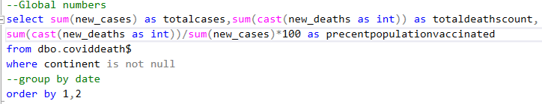.*



So we can see that the Total cases across the world is 609,151,106 and the total and the total death

Count is 6,481,786

1. The total number of life lost during the covid from 2020 to 2022 in Nigeria, the amount of people infected and the total population as at that time and also the percentages

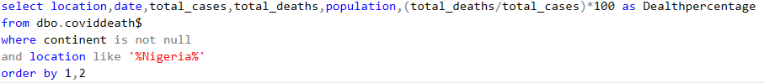



1. Countries that recorded the largest amount of dead people during the covid from 2020 to 2022



1. Continent that recorded the highest amount of dead people

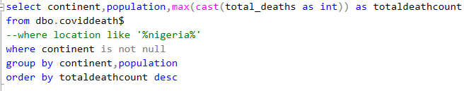

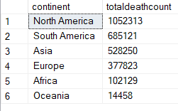

Tableau Visualizations.

The diagram shows a chart containing each chart of the sql above

1. This is the diagram of the global numbers

